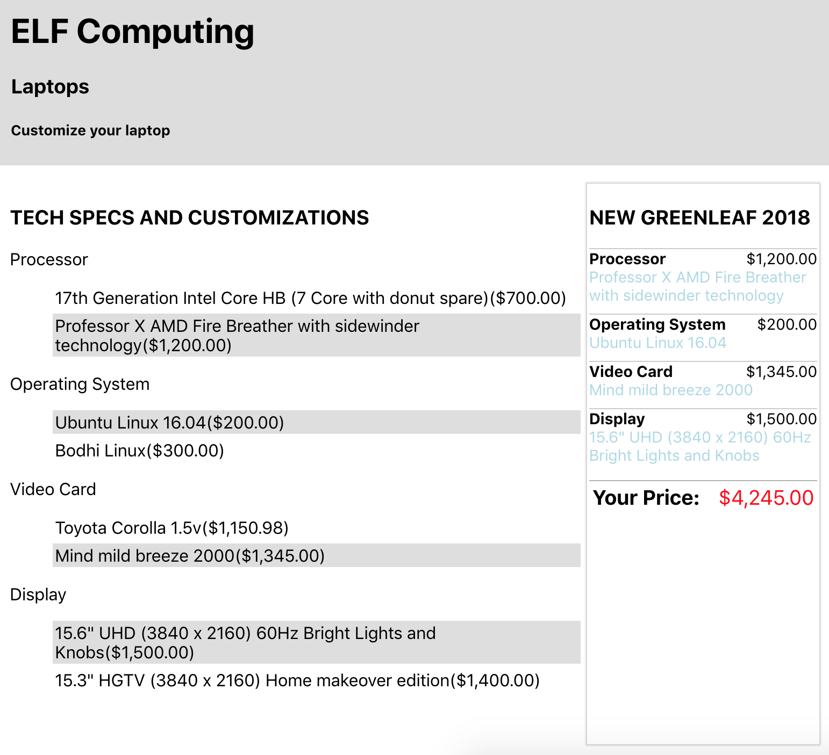

**App component –** everything

**Header** – may be reused throughout the site

**Tech Specs and Customizations** – List of the specs and customization options

**Custom Element** – each customizable part (processor, operating system, video card, display)

**Item to select** – the priced item that gets selected in the list

**Totals list** – Right side column providing summary of selections

**Item on totals list** – Item displayed by type, name, and price